The cost of young motherhood; shame, humiliation and irreparable damage

Mission to raise £40k to complete essential medical centre in Ethiopia inspired by tragedy suffered by young women across the country

The death of a schoolgirl in Lalibela, Ethiopia coupled with a chance encounter has inspired Trevor Parsons, 82 supported by his daughter, Helen Jamieson and her team at Jaluch to open a desperately-needed medical centre in a town over 5,000 miles away.

Young mothers across Ethiopia are suffering horrendous injury and humiliation as a result of being too physically underdeveloped to carry children. Many people in rural Ethiopia are thin, due to food shortages caused by uncertain rainfall. As a result many young mothers are not sufficiently physically developed to allow the birth of a baby to proceed naturally.

In the frequent absence of professional care in the countryside, efforts to expel the baby fail, and the dead child rots inside the mother. This causes the destruction of her own abdominal structures and the walls of the bladder and rectum break down, causing double severe incontinence.

Trevor has already sponsored a young nurse from Lalibela through six years of nursing training and has worked with him to build a medical centre in the remote town. The final hurdle is to now kit out the centre with the vital equipment needed to support the 35,000 families in the area, where men only expect to live to 49, and women to 51.

An devastating issue close to home
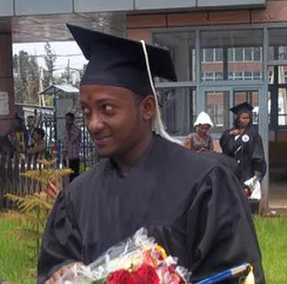
This issue came to Trevor’s attention of Trevor six years ago when he was visiting Lalibela. A chance encounter led to Trevor paying for a young farmer who was dying of gangrene to travel to a medical centre to have his arm amputated. On his return to England, Trevor stayed in touch with one of the young men he had met, called Adisu.

Adisu expressed his sadness and frustration with the lack of medical care available to his community - in particular the lack of care for women. The tragic death of a schoolgirl known to Adisu was a powerful driver of his ambition to improve the lives of women in Ethiopia. She had become pregnant after being accosted by two men while walking home from school.

Her young body was too small to carry the child, and when the pregnancy failed she as left with double incontinence. As with many in this horrible position, she killed herself after a few months of suffering constant humiliation.
As a boy, Adisu vowed to do something to help his rural community. He decided he would become a nurse and open a medical centre to support and educate his community.
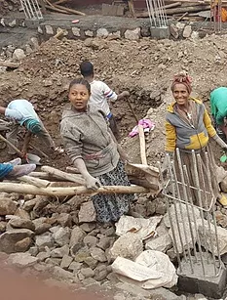
“Ethiopia is a desperately dangerous place for young mothers, in a country where child marriage is still the norm, much education is needed,” says Helen Jamieson, who is helping lead fundraising efforts through her company Jaluch, which sponsoring a number of rewards for donors.

Building stands, but needs vital equipment

Now, with Trevor’s support Adisu and his brother have overseen the building of the new medical centre, which is just about complete.
​
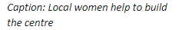
This life saving building has space for residential accommodation for the nursing and support staff, space for patients to be diagnosed and treated, space for outpatient clinics. The only way to realise this dream is for Trevor and his supporters to raise the final £40,000 needed for the vital equipment needed in the centre.

“This has become my life’s work and, once it is complete it will offer support to many men and women who lack basic healthcare and education,” said Trevor. “If we can encourage people to donate just a few pounds it will make a true difference to people just like us, who just happen to live thousands of miles away. They too deserve dignity and care, and with our help they can achieve it.”

--------------------------- END ------------------------

Donations to the Lalibela Medical Centre can be made at .gofundme.com/lalibela-medical-centre while more about the story, and the centre’s progress can be found at lalibelamedical.org.
​
For more information and interview contact:

Amy Sutton
Enjoy PR
amy@enjoypr.co.uk
07983416890

